Command To Run on Powershell:

Get-ADUser -Filter * -SearchBase "OU=People,OU=Resources,DC=adcu,DC=columbia,DC=edu" -Properties *| Select-Object Name,GivenName,Surname,Enabled,Description,userprincipalname,samaccountname,Mail,Title,Department,lastlogondate,WhenCreated,info| Export-csv C:\temp\ADusers.csv -NoTypeInformation
Use the attached file.
Change the File location to the drive on your folder:

Change the OU & DC as necessary. Use following to find the OU needed for users or check with your Active Directory Support team.
Open A command Prompt:
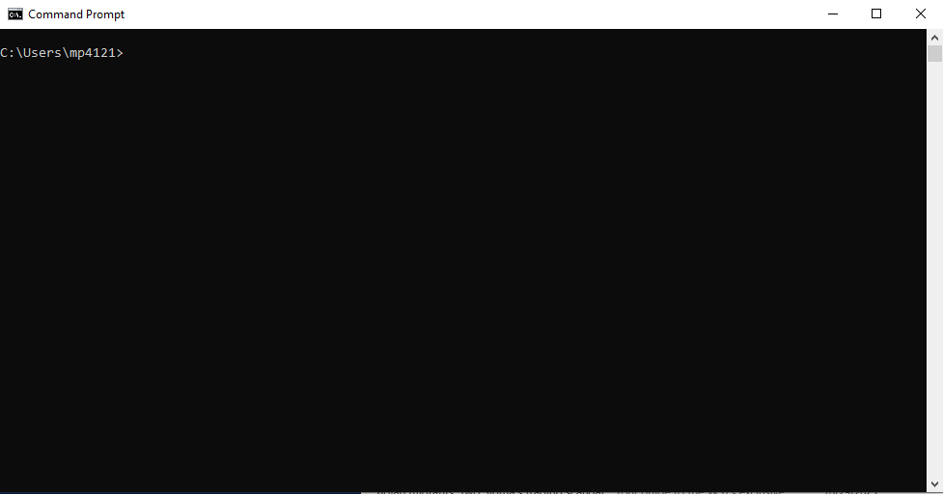
Run Command “dsquery user”
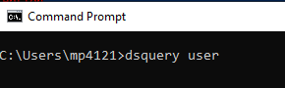
Identify the OU & DC to be replaced in the Powershell Script above.
